The procedure
I started by getting out my old draughting set and drawing up a pattern comprising six arcs, each with seven holes. With the master pattern done, I made a couple of copies that would be used for working templates. 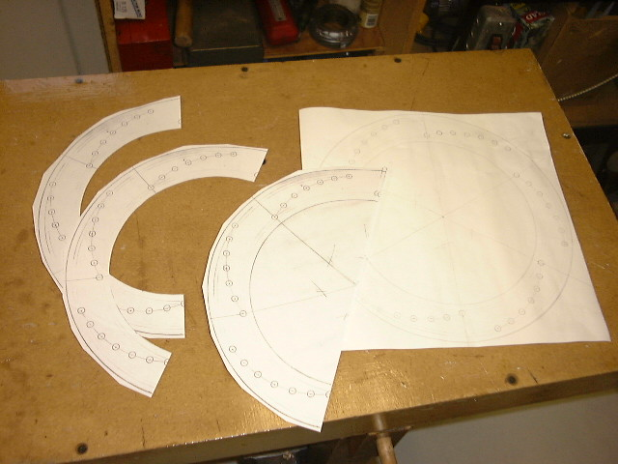
I taped the working template onto a solid rotor, center punched each hole, then got busy with the drill press. After a bit of clean-up and chamfering of each hole, here is the final product. Now, times two and you have a matched set for the front end.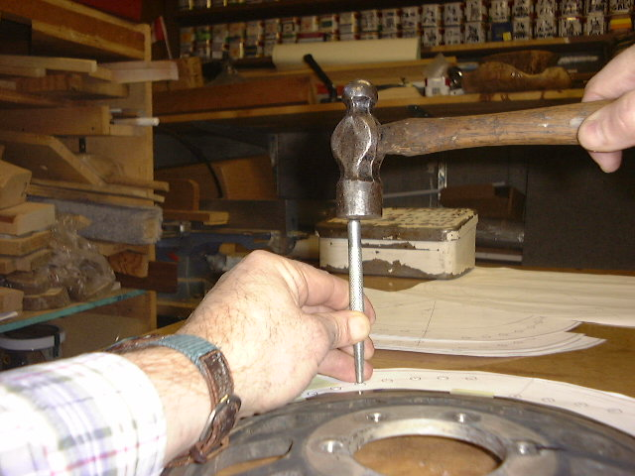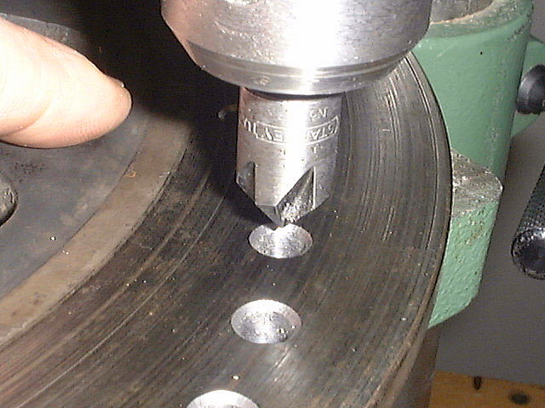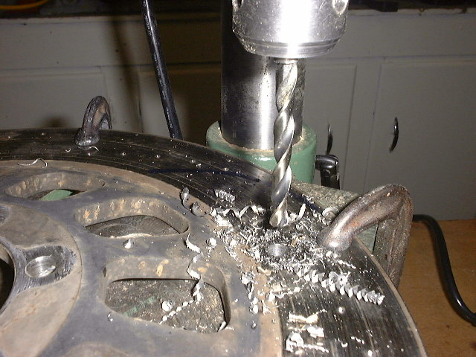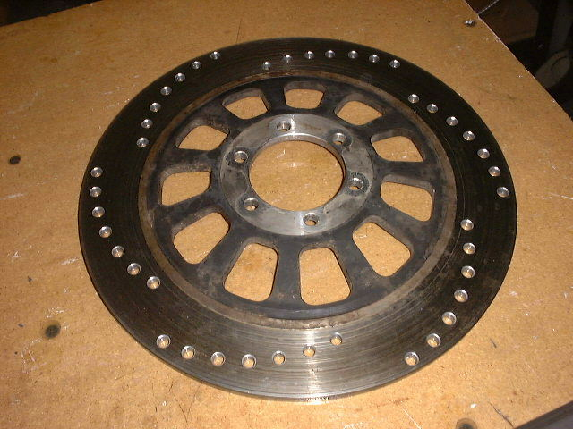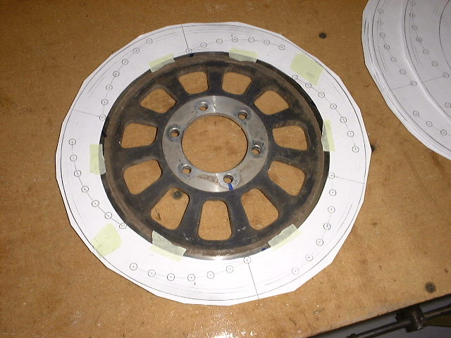
The Template
If you would like to try this yourself, here are two partial templates, one for the right side rotors, and one for the left side rotor , both in Adobe pdf format, sized to print out on a sheet of 8.5x11 paper. Print out a test copy and check the scales by measuring the 100mm scale bar.
You will need three partials for each rotor. Trim on the outside lines, and tape the three pieces together to form one template. Remember to use the correct template for each side.
Tips
- I used a 1/4" drill for all holes
- expect to take approx 1 to 2 hours per rotor
- run the drill press at 500 to 700 rpm
- use cutting oil to reduce heat and friction
- the rotors are hard, expect to get no more than about 20 holes per drill
- if you have access to a good drill bit sharpener, sharpen after each 10 or 15 holes, and try regrinding the drill to a split point rather than a standard point to reduce the amount of thrust required.
- remember that the left and right rotors should be mirror images of each other or you will have one set of holes looking like it is going backwards
- pay attention to alignment of the template on the rotor so you can make left and right appear to be synchronized, or offset by a desired amount. Note how the first drilled hole aligns with the only web which aligns with a mounting hole.
More Tips
(from someone who actually knows what he's talking about)
My two cents on drill bits, buy cobalt 135 deg split points. Run it at 50 SFPM (surface feet per minute) about 800 RPM for stainless steel. One drill should then drill all the holes. Use cutting oil no WD-40.
More Tips
(from a satisfied customer)
Well I was sitting around tonight looking at all the snow and decided to tinker with the ole xs. My rotors were sitting there calling my name. I printed Ken's template ( make sure if you use it to turn of the "shrink to fit page" option when printing ), taped it on, went nuts with the center punch and got down to drilling. I set my little $40 bench top drill press to turn at 600 and started to drill the first hole with a shiny new titanium bit. Cut, cut, cut, smoke, smoke, smoke, squeallllllllll, burned up bit halfway through. Argh, maybe this is out of my league..... Oooops like an idiot, I set the belt on the drill press to run at the fastest possible speed not the slowest. STUUUUUUUPID !!! Well, I belt the belt on properly, stuck a new bit in and drilled that puppy out in lightning speed. I only used one bit and it cut like butter through each hole. Ken's instructions and template are right on and excellent. Moral to the story - grab a cheap drill press and a bit from home depot, download and print Ken's tutorial and you to can have some pretty drilled rotors.
More Tips
(from the voice of experience)
There have been reports from times past [& personal experience] that patterns in rotors --- of whatever type (holes/slots/mixtures/&c.) are best not repeated exactly. By repeating patterns perfectly one has an OUTSIDE chance of setting up unwanted harmonics under certain conditions. It's best to vary the smaller groups by a few degrees. The eye will never see 3 or 4 degrees of variance. Don't worry about differential balance. Not enough to matter besides, it's in close [minimal rotational inertia]. Yer tire is out more than that. I've done several sets in the past and after I learned the trick never had another problem. If you ever see an XS 750 w/ a swirl "bubble" pattern it's pbly mine. [Swirled & increasing in hole diameter] Also, one of our Canuck Bros. has a set of rotors that have 210 holes per disc --- if I rmbr the count.
Another Pattern - For A Slotted Rotor
I could not take the peer pressure anymore and had to drill my slotted rotors while they were off the bike! The steel in these is fairly easy to drill, so the cobalt drill is a luxury but could be very useful if the drill press will not slow down enough.
Final Tips
(after finishing my third rotor)
Using a liberal amount of cutting oil makes a huge difference in the drilling. I set up my drill press inside a cardboard box to contain the cuttings and oil. On the first rotor, I used just a small dab of oil for each hole, and I got a lot of small chippings. By the time I got to the third rotor, I was using a very liberal amount for each hole, and what a difference! The drilling was noticeably smoother and the cuttings came off in consistently long spirals . Without any sharpening, my garden-variety HSS drill bit was still putting out cuttings like this on the final hole of one rotor. Even the chamfering was much smoother with the extra oil.
The time required turned out to be a nice surprise too as I had expected this to be a long, tedious process. Instead, I found the total time for each rotor to be about an hour and a quarter. This included everything from printing out the template sections to finishing with the chamfering.
If you do not have a drill press, you could still prepare the template, tape it to the rotor, then take it to a machine shop for drilling and chamfering. With my shadetree setup, I was able to Centre punch and drill a single rotor in about 45 minutes. A shop should charge no more than about an hour per rotor, or with a bit of luck and a speedy shop, as little as two hours for a set of three.

